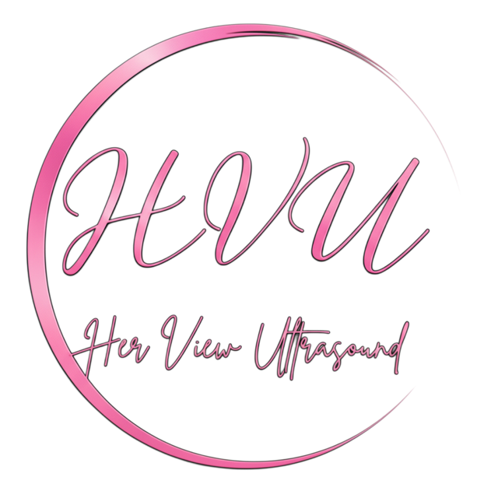
HER VIEW ULTRASOUND
Provider Order / Referral Form

Phone: 575-323-1130 Email: herview.us@proton.me Fax: 505-312-6009
225 E Idaho Ste 29, Las Cruces NM, 88005

PATIENT INFORMATION
Patient Name: | Date of Birth:
Address: | City / State / ZIP:
Phone: | Email:
Pregnant: ☐Yes ☐No | LMP: EDD:
Height: | weight:
SSN: | Insurance:
Medical hx: | Comments:

PROVIDER INFORMATION
Referring Provider: | NPI:
Clinic / Practice: | Phone:
Fax: | STAT Results Phone:

CLINICAL INFORMATION / ICD-10/ REASON FOR REFERRAL

ULTRASOUND EXAM REQUESTED
OBSTETRICS  ☐ OB <14 weeks  ☐ First trimester screening  ☐ OB >14 weeks  ☐ Detailed anatomy  ☐ OB Follow Up / Growth  ☐ OB Transvaginal  ☐ BPP without NST | GYNECOLOGY (NON‑OB)  ☐ Pelvic Complete  ☐ Pelvic Transabdominal  ☐ Pelvic Transvaginal  ☐ Pelvic Limited  ☐ IUD Check  ☐ Fertility Evaluation
__________________________________________________________________________________
Provider Signature Date

