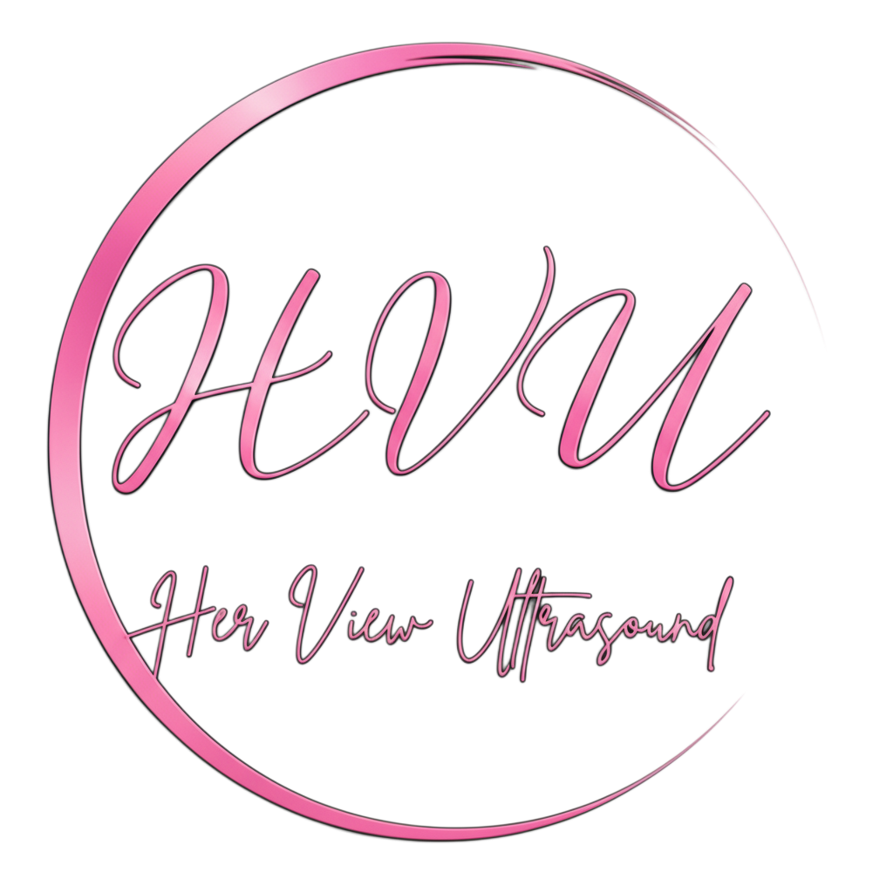
HER VIEW ULTRASOUND
Provider Order / Referral Form
Phone: 575-323-1130 FAX: 505-312-6009 Email: herview.us@proton.me

PATIENT INFORMATION
Patient Name: | Date of Birth:
Address: | City / State / ZIP:
Phone: | Email:
Pregnant: ☐Yes ☐No | LMP: EDD:
Height: | Pre-pregnancy weight:
SSN: | Insurance:
Medical hx: | Comments:

PROVIDER INFORMATION
Referring Provider: | NPI:
Clinic / Practice: | Phone:
Fax: | STAT Results Phone:

CLINICAL INFORMATION / ICD-10/ REASON FOR REFERRAL

ULTRASOUND EXAM REQUESTED
OBSTETRICS  ☐ OB <14 weeks (76801) ☐ Additional Fetus  ☐ First trimester screening (76813)  ☐ OB >14 weeks (76805)  ☐ Detailed anatomy (76811 if indicated)  ☐ Fetal echo (76825 if indicated)  ☐ OB Follow Up / Growth (76816)  ☐ OB Limited (76815)  ☐ OB Transvaginal (76817)  ☐ BPP without NST (76819) | GYNECOLOGY (NON‑OB)  ☐ Pelvic Complete (76856 + 76830 if indicated)  ☐ Pelvic Transabdominal (76856)  ☐ Pelvic Transvaginal (76830)  ☐ Pelvic Limited (76857)  ☐ IUD Check  ☐ Fertility Evaluation
Provider Signature: ________________________________________________Date:______________________

